**CS6P05NI - Project**

**Project Proposal Draft**

**2023 Autumn**

**Student Name: Rayan Dongol**

**London Met ID: 21039918**

**College ID: NP01CP4A210078**

**External Supervisor: Hitesh Shrestha**

**Internal Supervisor: Yunisha Bajracharya**

**Assignment Due Date: Friday, October 13, 2023**

**Assignment Submission Date: Friday, October 13, 2023**

**Word Count: 2164**

*I confirm that I understand my coursework needs to be submitted online via MySecondTeacher under the relevant module page before the deadline in order for my assignment to be accepted and marked. I am fully aware that late submissions will be treated as non-submission and a marks of zero will be awarded.*

**Table of Contents**

1 Introduction 1

1.1 Problem Scenario 2

1.2 Project as a solution 3

2 Aim and Objectives 4

2.1 Aim 4

2.2 Objectives 4

3 Expected Outcomes and Deliverables 5

4 Project Risks, Threats and Contingency Plans 5

4.1 Project Risks, Threats 5

4.2 Contingency Plans 6

5 Methodologies 7

5.1 Chosen Methodology: Agile Methodology – Scrum Framework 7

6 Resource Requirements 8

6.1 Software Requirements 8

6.2 Hardware Requirements 8

7 Work Breakdown Structure 9

8 Milestones 10

9 Project Gantt Chart 12

10 Conclusion 13

11 Bibliography 14

**Table of Figures**

Figure 1: WBS 9

Figure 2: Gantt Chart 12

# Introduction

Nepal is known famously for its natural beauty and as a great place to visit for vacations and sightseeing. The breath of fresh air along with its breathtaking views and diverse culture leads to it being on the bucket list of places to visit for many foreigners. The developments made by Nepal in the sector of tourism in recent years helped Nepal grow financially resulting in tourism playing a major role in the country’s economy. Tourism in Nepal only started after 1975 when they became a member of The World Tourism Organization. The Nepal Tourism Board was established much later in 1998. Since then, the tourism industry has not looked back and has gradually grown and become an integral part of Nepal’s economy. (Anupam, 2022)

Taking advantage of the tourism industry of Nepal as it continuously grows and the fact that this industry employs over three hundred thousand people, this sector can provide great employment opportunities. Travel agencies, tour guides, hotels, transportation and other tourist services flourish if given priority and proper support. (Shrestha, 2023) Multiple campaigns such as the three Visit Nepal campaigns in 1998, 2011, and 2020 have helped bring light to Nepal’s tourism industry but those campaigns were not as successful as they were deemed to be due to different circumstances such as COVID-19 pandemic and armed conflicts. Efforts are being made but fall short failing in achieving its full potential. (Anupam, 2022)

## Problem Scenario

In Nepal, the tourism industry tends to fall behind with publicity and the inability to truly promote the facilities and benefits that are provided. Tourism establishments, tour agencies, guides, and transportation are not given proper platforms to advertise their excellent services and skills.

The tourism sector contributes to 6.7% of Nepal’s GDP and employs over three hundred thousand people. This translates to roughly 11.5% of all workers across all sectors of the economy. (Prasain, 2021) The COVID-19 pandemic drastically set back the improvements made by the tourism industry with a massive decrease in revenue and the decrease in the number of tourists visiting. This resulted in the decline of the GDP contribution and the industry contributed 46.6% less to overall GDP. (Dhakal, 2022) The industry is gradually recovering from the setbacks and has seen massive increases in tourists visiting Nepal. An increase of over four hundred thousand tourists was seen between the years 2021 and 2022. (Ministry of Culture, Tourism & Civil Aviation, 2023)

As Nepal has an immense number of tourism establishments, roughly 14.6% of all establishments, proper hospitality for tourists is a must. (Prasain, 2021) A platform that fulfills the role of displaying the facilities provided by travel and touring agencies of Nepal is required. For tourists or even domestic travelers, viewing/booking hotels, organizing trips, and managing the route is a massive hassle. Sure, some travel agencies have proper websites, but the majority of the others have poorly maintained websites that are difficult to use with poor user experience. Nepal has proper facilities and hospitality but without proper exposure showcasing it, it becomes a challenge to book hotels, guides, and plan trips.

## Project as a solution

In today’s scenario, the exposure in the world of the internet of our tourism industry is very shallow. Very few travel agencies in Nepal tend to have a dedicated website for the public to view. A website that lists all the packages of a travel agency and displays the required details such as the price, tour guide, estimated duration, etc. With features such as comparing two packages, budget planning, planning custom trips, and customer reviews. This project allows domestic as well as international tourists to plan their trips in Nepal with ease as they can pick and choose between multiple agencies or customize their trips themselves.

The major solutions are as follows:

1. **Platform for displaying available tour packages:**

The website allows users to view destinations, hotels, tour details, and information provided by registered touring agencies. This gives exposure to agencies failing to promote their business and facilities and those without proper websites. The users can also compare multiple packages and pick what’s suitable for them.

1. **Rating and reviews, feedback:**

Allowing users to rate and give feedback lets the agencies know the places where they can improve. This feedback would also be of great help as it would highlight the problems many international tourists or domestic visitors face.

1. **Plan and set a budget allowing customized trips:**

The project allows users to set a budget and allows user to plan and manage their trips by setting a starting and an ending destination. It allows users to be flexible with their budget and displays what is best suitable for them.

# Aim and Objectives

## Aim

The project aims to promote Nepal’s tourism industry and make life easier for people planning on going on tours, by providing necessary details of the tour while acting as a platform for different agencies to showcase their facilities.

## Objectives

1. Creating an interactive and dynamic web application that allows planning trips in Nepal.
2. Providing role-based authorization such as registered user, tour guide, travel agency which gives different users different features according to their role.
3. Implementing a feature that displays the packages provided by Travel agencies along with all the necessary details such as price, tour description, and booking details allows users to compare different packages.
4. Developing a rating system that allows users to rate different trips they have been to and share their experiences.
5. Developing a budget planner/calculator that displays the available packages according to the user’s budget.
6. Implementing maps for accessing and displaying locations of different hotels and places to visit.
7. Implementing a payment method for easy transactions.

# Expected Outcomes and Deliverables

1. A Website that allows the user to log in and register. Users can register as normal users or as travel and tour agencies with both users having different features.
2. A normal user can view, book tours, manage budgets, compare packages accordingly, and complete payments. A travel agency can upload/display their tour packages with the necessary information.
3. The users have their profile page where they can view their reviews, bookmarked packages, and update their information. Travel agencies will also have their profile that displays only their packages.
4. The user can effectively book a tour through the provided packages with proper dates and payment.
5. Users can view and give reviews and rate the experience.
6. Dashboard that displays packages with offers provided by different agencies.

# Project Risks, Threats and Contingency Plans

## Project Risks, Threats

1. Spam/Fake Accounts

As registering and logging in only takes an email and a password, the credibility of accounts is a great concern. These accounts could also give out fake reviews and give a bad image to other travel agencies.

1. Time constraint for the completion of the project

Managing and working with the given amount of time to complete the project is very important. Failure to do so results in major consequences.

1. Server/Technical Failures

Server crashing, website not loading, and slowing down, are some of the few examples of technical failures that immediately pose a great obstacle to the success of the website. A slow website translates to a terrible user experience,

1. Issues with payment

When using online payment methods, there are constant problems that may or may not be in the control of the user or the website’s server but rather the bank itself.

1. Cybercrimes

Cybercrime is a threat faced by companies of any size, and taking measures to decrease the likelihood of such a threat occurring should be the number one priority when it comes to a safe and secure website.

1. Data Security

The users trust the company with their data and information, it is only ethically and morally correct that their data is kept secure and is not distributed to other organizations without their consent.

## Contingency Plans

1. Failure to implement payment:

If due to some unforeseen circumstances, there is a failure to implement a payment system using eSewa, alternatives such as Khalti and Fonepay could be considered.

1. Database:

The desired database for this project is PostgreSQL while MySQL is the alternative.

1. Maps feature:

Implementing the maps feature is a difficult task and requires working with Google’s APIs and could be quite costly. Using Galli maps could be considered if there are problems.

# Methodologies

## Chosen Methodology: Agile Methodology – Scrum Framework

The Agile Software Development Methodology follows the principles of iterative approach which helps break down the project into multiple parts. This leads to flexible and adaptable projects where the client is constantly participating throughout the development life cycle and provides constant feedback. This leads to a product that can adapt as it gets developed and ultimately satisfies the needs of the client. (Brush, 2022)

The Scrum Framework is one of the most frequently used frameworks of Agile Methodology. The work among the team is divided and the time frame for the completion of one increment is estimated. This time period is known as sprint. Sprints are typically two weeks long. (AWS, 2023) Following the scrum framework divides the workload and assigns it to particular roles and responsibilities. These roles include the product owner, scrum master, and the scrum team. For properly implementing the scrum framework and managing work, scrum uses three artifacts, the product backlog, sprint backlog, and increment. (Wrike, 2023)

The methodology I have chosen certainly benefits when working in groups, but as this is an individual project, the benefits and advantages that Scrum provides simply cannot be overlooked. The incremental and iterative approach and dividing the workload into multiple sprints massively improves efficiency and productivity.

# Resource Requirements

## Software Requirements

* IDE – Visual Studio Code and PyCharm
* Database – PostgreSQL
* Frontend: HTML/CSS and JavaScript
* Backend: Python – Django Framework
* Design/Prototypes - Figma/Adobe XD
* Project Management Tool – Jira

## Hardware Requirements

* A modern computer/laptop used for development purposes.
* A stable, high-speed internet connection.

# Work Breakdown Structure

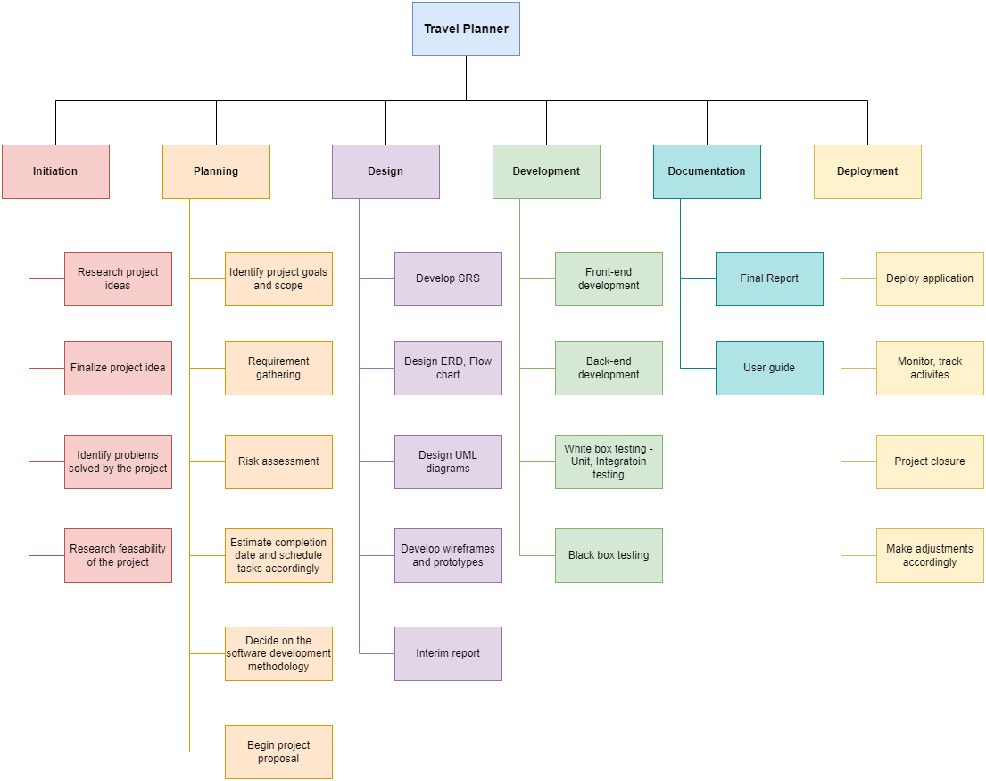

Figure 1: WBS

# Milestones

* **Milestone 1 Finalize topic for the project:**

After multiple research and queries with my supervisors, the project on the topic of Travel Planner was finalized.

* **Milestone 2 Proposal Submission:**

The completion of the proposal lays out the foundation for the completion of the project. With an approved proposal the project can continue further. This proposal contains the key aspects of the project and its features along with the requirements and research needed for future developments in the project.

* **Milestone 3 UML Diagrams:**

UML diagrams such as use case, sequence, and class diagrams are extremely useful. This showcases all the requirements and functionalities of the project.

* **Milestone 4 Designing:**

Building form, the foundation laid out by the proposal, and the blueprint for the project are required. The completion of designing wireframes and prototypes of the user interface of the project is essential while also creating a smooth-sailing user experience making it as user-friendly as possible.

* **Milestone 5 Interim Report:**

The interim report plays a major role in the completion of the project. It is a follow-up of the proposal report and is heavily influenced by the proposal. It explains the project in complete detail.

* **Milestone 6 Development:**

This milestone is dedicated to a functioning database with proper front end and back end. This milestone is near the end and is the coding aspect of the project.

* **Milestone 7 Testing & Debugging:**

Testing plays a vital role in ensuring an excellent user experience. After the completion of developing the complete website, it should be thoroughly tested. Debugging found bugs, and errors and giving the project the final touches.

* **Milestone 8 Deployment:**

After thorough testing and being satisfied with the project, in this milestone, the project is deployed for public use.

* **Milestone 9 Final Report:**

Documenting the whole journey with a proper report that excellently documents the project is created.

# Project Gantt Chart

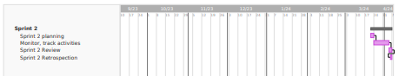

Figure : Gantt Chart

# Conclusion

The idea of building a travel planner as my Final Year Project has been decided. It aims to help Nepal’s travel and tourism industry. This proposal lays the foundation for the project and showcases the research that has been done. The main goal of the project was to create a website that acts as a platform for lesser-known travel agencies and organizations to showcase their packages and features without needing to create and manage a website. It also aims to help improve the tourist experience.

After the pandemic, the tourism industry is slowly gaining momentum and is beginning to gradually return to its peak, promoting it through the internet is the best bet. With the implementation of this project, I hope to help solve the problems regarding the exposure of our country’s tourism industry.

Finally, I would like to thank my external supervisor, Mr. Hitesh Shrestha sir, and my internal supervisor Ms. Yunisha Bajracharya ma’am for their guidance throughout this proposal. They have provided immense help and this idea would not have been completed without their help.

# Bibliography

Anupam, B., 2022. *The Farsight.* [Online]   
Available at: https://farsightnepal.com/news/81#:~:text=On%2018%20February%201951%2C%20the,international%20tourists%20arrived%20in%20Nepal.  
[Accessed 11 October 2023].

AWS, 2023. *Amazon Web Services.* [Online]   
Available at: https://aws.amazon.com/what-is/scrum/  
[Accessed 10 October 2023].

Brush, K., 2022. *TechTarget.* [Online]   
Available at: https://www.techtarget.com/searchsoftwarequality/definition/agile-software-development  
[Accessed 10 October 2023].

Dhakal, S., 2022. *LinkedIn.* [Online]   
Available at: https://www.linkedin.com/pulse/revival-nepalese-tourism-industry-challenges-moving-beyond-dhakal?trk=article-ssr-frontend-pulse_more-articles_related-content-card  
[Accessed 12 October 2023].

Ministry of Culture, Tourism & Civil Aviation, 2023. *Nepal Tourism Statistics 2022,* Kathmandu: Ministry of Culture, Tourism & Civil Aviation.

Prasain, S., 2021. *The Kathmanu Post.* [Online]   
Available at: https://kathmandupost.com/money/2021/06/17/tourism-is-nepal-s-fourth-largest-industry-by-employment-study  
[Accessed 12 October 2023].

Shrestha, S., 2023. *myRepublica.* [Online]   
Available at: https://myrepublica.nagariknetwork.com/news/boosting-nepal-s-economy-through-tourism/  
[Accessed 11 October 2023].

Wrike, 2023. *Wrike.* [Online]   
Available at: https://www.wrike.com/project-management-guide/faq/what-is-scrum-in-agile/  
[Accessed 10 October 2023].